The Booley Project
Seeking asylum seeker artists aged 19-26 (musicians, poets, writers, storytellers, dancers, activists, filmmakers, craftspeople, etc.) to participate in The Booley Project.

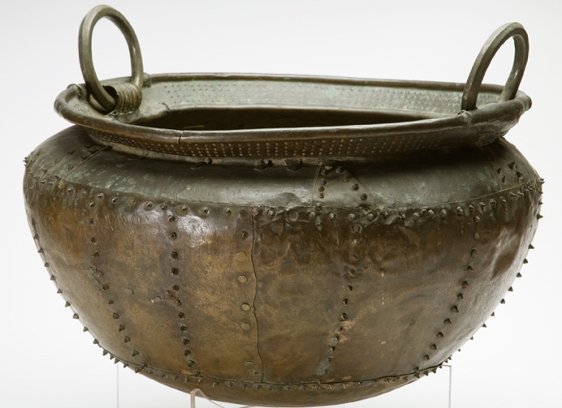
The Booley Project is designed to empower asylum seekers aged 19-26 to build community, develop skills and engage with Irish communities. Through a series of facilitated workshops we will work to develop a series of cultural projects in small groups. You, the participants, will choose the medium (song/music/poetry/film/art/ movement - or a combination) and engage in a creative process to tell a story or produce work on a theme. Upon completion each group will present their finished work to their peer groups at an all-day conference in Dublin. Then in summer we will travel to day-long cultural exchanges with host communities in Donegal, Mayo, Galway, Kerry and Cork. Upon completion of the project participants will receive a stipend, travel expenses and a certificate.
Apply at: www.cualafoundation.com/Booley
For more information email: contact@cualafoundation.com
A Cuala project supported by the International Protection Integration Fund
